**Software Requirements Specification**

**for**

**<Project>**

**Version 1.0 approved**

**Prepared by <author>**

**<organization>**

**<date created>**

**Table of Contents**

**Table of Contents**

**Revision History**

**1. Introduction**

1.1 Purpose

1.2 Document Conventions

1.3 Intended Audience and Reading Suggestions

1.4 Product Scope

1.5 References

**2. Overall Description**

2.1 Product Perspective

2.2 Product Functions

2.3 User Classes and Characteristics

2.4 Operating Environment

2.5 Design and Implementation Constraints

2.6 User Documentation

2.7 Assumptions and Dependencies

**3. External Interface Requirements**

3.1 User Interfaces

3.2 Hardware Interfaces

3.3 Software Interfaces

3.4 Communications Interfaces

**4. System Features**

4.1 System Feature 1

4.2 System Feature 2 (and so on)

**5. Other Nonfunctional Requirements**

5.1 Performance Requirements

5.2 Safety Requirements

5.3 Security Requirements

5.4 Software Quality Attributes

5.5 Business Rules

**6. Other Requirements**

**Appendix A: Glossary**

**Appendix B: Analysis Models**

**Appendix C: To Be Determined List**

**Revision History**

|  |  |  |  |
| --- | --- | --- | --- |
| **Name** | **Date** | **Reason For Changes** | **Version** |
|  |  |  |  |
|  |  |  |  |

1. **Introduction**
   1. **Purpose**

*<Identify the product whose software requirements are specified in this document, including the revision or release number. Describe the scope of the product that is covered by this SRS, particularly if this SRS describes only part of the system or a single subsystem.>*

This document represents the Requirement Analysis and Specification Document (RASD) for the software system myTaxiService, and the main goal of this document is to completely describe the system in terms of functional and non-functional requirements, analyse the needs of the customer, and represent the constraints and the limitations of the software. Also typical use cases and scenarios will be presented.

This document is intended to be used by developers, programmer and testers, who will implement and test the system, system analysts and requirement analysts for inter related systems, project managers, customers and users of the system.

* 1. **Scope**

*<Provide a short description of the software being specified and its purpose, including relevant benefits, objectives, and goals. Relate the software to corporate goals or business strategies. If a separate vision and scope document is available, refer to it rather than duplicating its contents here.>*

Software system myTaxiService is a project meant to optimize the taxi services of the city, by providing the mobile and web application that will allow users to request a taxi, or book the ride in advance and cancel the ride. It will also provide a fair management of taxi queues for the taxi drivers, and maximize the profit for the city.

In particular, city is divided into taxi zones, and each zone is assigned to a taxi queue (the system automatically calculates the distribution of taxis in zones based on the GPS information it receives from taxis). If the taxi is available (this information is provided by the taxi driver, who informs the system about his/hers availability through a mobile application), its identifier is stored in a queue of taxis in the corresponding zone. When a user requests a taxi from a zone (through a mobile or web application), the system forwards it to the first taxi queuing in that zone. Taxi driver can then confirm or deny the request through the mobile application. If the request is denied system will forward the request to a next taxi in the queue (and move the first taxi to the end of the queue), or if the queue is empty it will make sure that another taxi gets a request. When the taxi driver confirms the request, the passenger will be informed by the system about the taxi identifier and the waiting time. The passenger can also book a taxi, specifying the starting point and the destination, and the system then allocates a taxi 10 minutes before the meeting time with the passenger.

The system will also provide programmatic interface to enable development of additional services on top of the basic one.

1.3 **Actors**

* Visitor - A person that is not registered for the service, or a registered user who is not logged in to the application. Visitor can only see the home page, registration from and log in form.

* Registered users - A person that has an account for myTaxiService.

* User - A logged in registered user.

* Passenger - A user that uses myTaxiService for the means of requesting and reserving a taxi ride.

* Driver - A user of the mobile application, that drives a taxi, and uses the application for receiving the requests for the ride.

* Administrator - Supervisor, manages databases, and also takes care of drivers responsibility.

1.5 **Goals**

List of the goals for myTaxiService:

* [G2] Allow visitors to register to the application.

* [G3] Allow registered users to log in to the application, with same credentials for both the web and the mobile application.

* [G4] Passenger can request a taxi ride by specifying his starting point and his destination.

* + [G4.1] When requesting a taxi ride, passenger can specify either his starting point or destination or both by selecting the points on the map for the locations.
  + [G4.2] When requesting a taxi ride, passenger can specify either his starting point or destination or both by typing in the address of the locations.

* + [G4.3] When requesting a taxi ride, passenger can specify his starting point by revealing his/hers GPS location.
  + [G4.1] The passenger will be notified on request with the taxi code, waiting time and the fare amount.

* + [G4.2] The passenger can either accept or cancel the taxi proposal.
  + [G4.3] If the taxi proposal is accepted, taxi is dispatched and will arrive at the requested location in 15 minutes maximum.

* [G5] Passenger can reserve a taxi ride specifying his starting point, his destination and the desired time, at least two hours before the ride

* + [G5.1] When reserving a taxi ride, passenger can specify either his starting point or destination or both by selecting the points on the map for the locations.

* + [G5.2] When requesting a taxi ride, passenger can specify either his starting point or destination or both by typing in the address of the locations.

* [G6] When the passenger reserves a taxi ride, he will be informed with a code of the incoming taxi 10 minutes before the specified time of the ride.
* [G7] passenger can cancel his request.
* [G8] passenger can cancel his reservation.
* [G8] The passenger has to pay for the accepted ride, either the request or the reservation, through the application.

* [G9] Available driver can confirm or reject the certain request for the ride.

1.4 **Definitions, Acronyms, Abbreviations**

1.4.1 **Definitions**

* Available driver - is a driver who informed the system that he is available for the rides.

* Proposed taxi - is a taxi, that is not yet allocated by the system, but accepted the request.

1.4.2 **Acronyms**

* RASD - Requirements Analysis and Specification Document

* DBMS - Data Base management system

* DB - Data Base

* API - Application Programming Interface

* OS - Operating System

1.4.3 **Abbreviations**

* [Gn] - n-th Goal

* [Rn] - n-th Functional Requirement

* [Dn] - n-th Domain Assumption

* [Mn] - n-th Mockup
  1. **References**

*<List any other documents or Web addresses to which this SRS refers. These may include user interface style guides, contracts, standards, system requirements specifications, use case documents, or a vision and scope document. Provide enough information so that the reader could access a copy of each reference, including title, author, version number, date, and source or location.>*

* Specification Document: myTaxiService Project, AA 2015-2016

.

* IEEE Std 830-1998 IEEE Recommended Practice for Software Requirements Specifications.

1.6 **Document Overview**

This document is structured in four parts:

* Section 1 - Introduction. It gives a description of document and some basic information about software.
* Section 2 - Overall Description. Gives general information about the software product with more focus about constraints and assumptions.
* Section 3 - Specific Requirements. This part lists requirements, typical scenarios and use cases. To give an easy way to understand all functionality of this software, in this section UML diagrams are given.
* Section 4 - Appendix. This part contains some information about the attached .als file and some described screenshot of software used to generate it.

1. **Overall Description**
   1. **Product Perspective**

*<Describe the context and origin of the product being specified in this SRS. For example, state whether this product is a follow-on member of a product family, a replacement for certain existing systems, or a new, self-contained product. If the SRS defines a component of a larger system, relate the requirements of the larger system to the functionality of this software and identify interfaces between the two. A simple diagram that shows the major components of the overall system, subsystem interconnections, and external interfaces can be helpful.>*

The system myTaxiService is a project being developed for the government of city X. It will be released as a new, self-contained product, not integrated with other existing systems. Users will be able to access the service through a web and mobile application. The application will have a internal interface for administration, and it will provide API to enable the development of additional services on top of the basic one.

* 1. **Product Functions**

*<Summarize the major functions the product must perform or must let the user perform. Details will be provided in Section 3, so only a high level summary (such as a bullet list) is needed here. Organize the functions to make them understandable to any reader of the SRS. A picture of the major groups of related requirements and how they relate, such as a top level data flow diagram or object class diagram, is often effective.>*

* 1. **User Classes and Characteristics**

*<Identify the various user classes that you anticipate will use this product. User classes may be differentiated based on frequency of use, subset of product functions used, technical expertise, security or privilege levels, educational level, or experience. Describe the pertinent characteristics of each user class. Certain requirements may pertain only to certain user classes. Distinguish the most important user classes for this product from those who are less important to satisfy.>*

* 1. **Operating Environment**

*<Describe the environment in which the software will operate, including the hardware platform, operating system and versions, and any other software components or applications with which it must peacefully coexist.>*

* 1. **Design and Implementation Constraints**

*<Describe any items or issues that will limit the options available to the developers. These might include: corporate or regulatory policies; hardware limitations (timing requirements, memory requirements); interfaces to other applications; specific technologies, tools, and databases to be used; parallel operations; language requirements; communications protocols; security considerations; design conventions or programming standards (for example, if the customer’s organization will be responsible for maintaining the delivered software).>*

2.5.1 **Regulatory Policies**

* Privacy Policy - It fulfills a legal requirement to protect a customer or client's privacy.
* Online Payment Policy - satisfies a safe online transactions.

2.5.2 **Hardware Limitations**

myTaxiService doesn’t have any hardware limitations.

2.5.3 **Interfaces to other applications**

* Online transactions -
* Maps -

2.5.4 **Parallel operations**

myTaxiService must support parallel operations from different users when working with database and with all operation done by the user after connection.

2.5.5 **Documents related**

* Requirements and Analysis Specification Document (RASD).
* Design Document (DD).
* User’s Manual.
* Testing report.
  1. **Assumptions and Dependencies**

*<List any assumed factors (as opposed to known facts) that could affect the requirements stated in the SRS. These could include third-party or commercial components that you plan to use, issues around the development or operating environment, or constraints. The project could be affected if these assumptions are incorrect, are not shared, or change. Also identify any dependencies the project has on external factors, such as software components that you intend to reuse from another project, unless they are already documented elsewhere (for example, in the vision and scope document or the project plan).>*

* This system will only be used only for government taxi service.
* Taxi service owns the vehicles, and the drivers work for the government.
* Taxi service is available 24 hours a day.
* Each taxi has a mobile phone, GPS system and a driver.
* Passenger has to pay if he accepts the taxi proposal.
* If a passenger cancels a taxi ride, he will be refunded 50% of the amount he paid.
* If a passenger cancels a taxi reservation before 48 hours, he will be refunded 70% of the amount he paid.
* If the passenger is not available at the pick up point, taxi waits up to 15 minutes, and after that the reservation is canceled, and the passenger is refunded 30% of the amount he paid.
* Passenger can reserve a taxi at least 2 hours before the desired time, and at most 1 week before the desired time.

2.7 **Future Possible Implementation**

* Taxi Sharing - if several people from the same zone are requesting a taxi, and going to the same direction, they can share it and split the expenses.
* myTaxiService Credits - possibility to pay for the rides with credits (e-money), that you can charge at the taxi stations, with your card or at some shops.

1. **External Interface Requirements**
   1. **User Interfaces**

*<Describe the logical characteristics of each interface between the software product and the users. This may include sample screen images, any GUI standards or product family style guides that are to be followed, screen layout constraints, standard buttons and functions (e.g., help) that will appear on every screen, keyboard shortcuts, error message display standards, and so on. Define the software components for which a user interface is needed. Details of the user interface design should be documented in a separate user interface specification.>*

In the following sections, mockups of the graphical user interface for the mobile application will be presented. Mockups for the web application are not presented here, but the layout will be the same for both mobile and web application.

3.1.1 **Registration and Log in**

This is the page that a visitor sees. Visitors can register or log in with their credentials here.

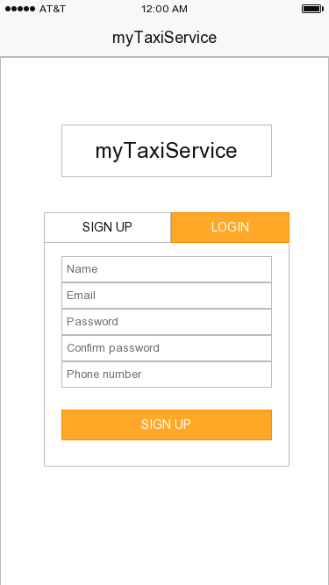

3.1.2 **Side Bar**

In the side bar user can find all of the relevant link to the application services, including requesting and reserving the taxi, and updating he's profile informations or reviewing his request and reservations.

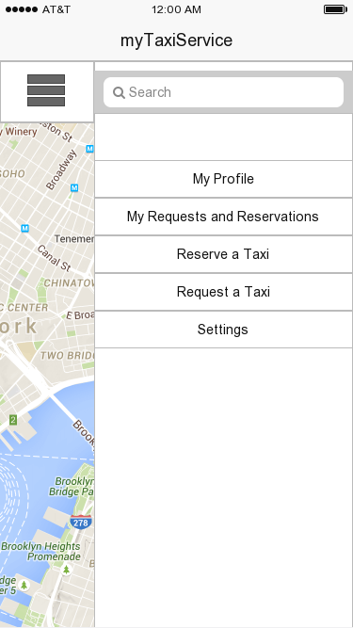

3.1.3 **Request a Taxi**

On this page user can request a taxi specifying his starting point and destination, either on the map or entering the addresses in the text fields, or selecting one of his saved addresses, or using his GPS location.

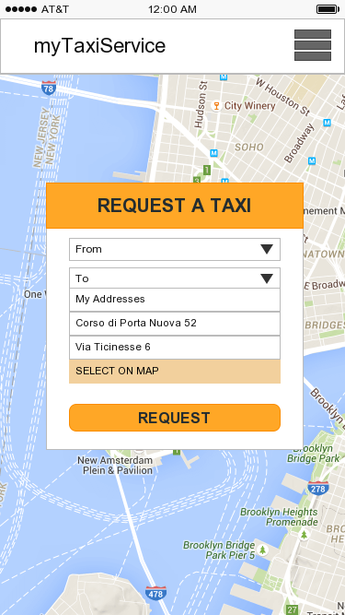

3.1.4 **Reserving a Taxi**

On this page user can reserve a taxi in advance, specifying his starting point and destination as well as the time, either on the map or entering the addresses in the text fields, or selecting one of his saved addresses.

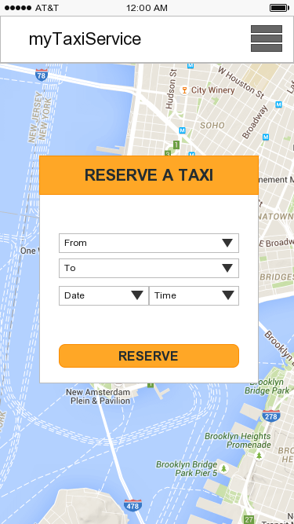

3.1.5 **Taxi ride confirmation page**

This is the notification page with all the details for the ride, when the system finds an available taxi. User is prompted to confirm, and to pay for the ride.

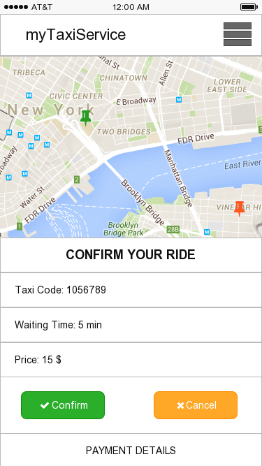

3.1.6 **Profile**

This is the profile page of the user, with all his personal information, that he can edit, as well as the list of his frequently used addresses and payment methodes.

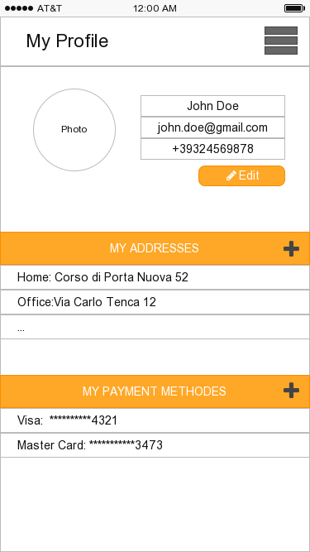

3.1.7 **My Request and Reservations**

This is the page where all the taxi requests and reservations of the user are displayed. From this page user can cancel his request or reservations, or generate a new request or reservation.

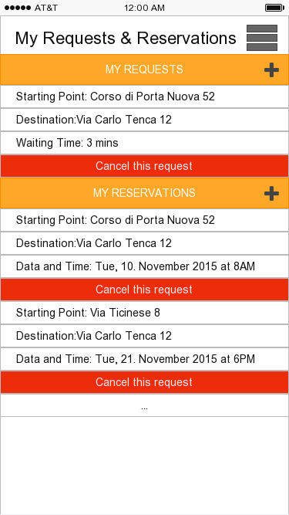

3.1.7 **Drivers Request Screen**

This is the drivers screen from where he can receive requests for the rides

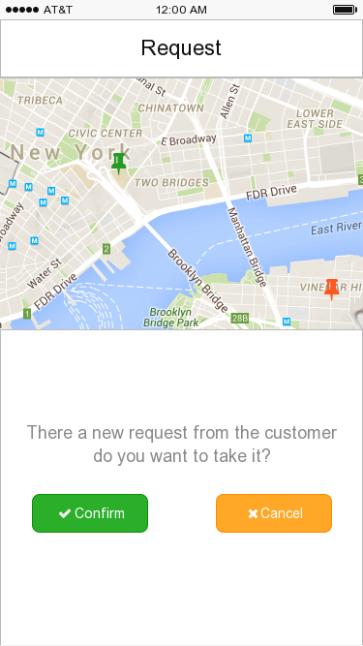

* 1. **API Interface**

myTaxiService will use two APIs:

* Google Maps API - for the maps, address seletction, route visualization.
* PayPal - the application will support payment through PayPal, for taxi rides, and refund of customer payment in cases of cancelation.
* Areapay API - The service enables payment from a user's mobile device directly to an application provider.
  1. **Hardware Interfaces**

*<Describe the logical and physical characteristics of each interface between the software product and the hardware components of the system. This may include the supported device types, the nature of the data and control interactions between the software and the hardware, and communication protocols to be used.>*

* 1. **Software Interfaces**

*<Describe the connections between this product and other specific software components (name and version), including databases, operating systems, tools, libraries, and integrated commercial components. Identify the data items or messages coming into the system and going out and describe the purpose of each. Describe the services needed and the nature of communications. Refer to documents that describe detailed application programming interface protocols. Identify data that will be shared across software components. If the data sharing mechanism must be implemented in a specific way (for example, use of a global data area in a multitasking operating system), specify this as an implementation constraint.>*

* Data Base - The database that the system is going to use is postgreSQL, version 9.4
* Python - For the backend, Python version 3.4 will be used.
* Nginx - For the web server
* Operating System - For the server ubuntu 14.04 will be used.
* jQuery - JavaScript library. Will be used for client side scripting
* Java - Will be used to develop the Android App
* Objective C - for the iOS app
  1. **Communications Interfaces**

*<Describe the requirements associated with any communications functions required by this product, including e-mail, web browser, network server communications protocols, electronic forms, and so on. Define any pertinent message formatting. Identify any communication standards that will be used, such as FTP or HTTP. Specify any communication security or encryption issues, data transfer rates, and synchronization mechanisms.>*

* HTTPS - 443
* HTTP - 80
* DB (For PosgreSQL) - 5432
* FTP (Data Transfer and Control) - 20, 21
* SSH (Remote Login) - 22

3.2 **Functional Requirements**

*<This template illustrates organizing the functional requirements for the product by system features, the major services provided by the product. You may prefer to organize this section by use case, mode of operation, user class, object class, functional hierarchy, or combinations of these, whatever makes the most logical sense for your product.>*

3.2.1 [G1] **Allow visitors to register to the application.**

[R1] Visitor has to fill and submit the registration form (Name, Email, Password and Phone number).

[R2] The Name, Email and Phone number should not match any other users data.

[D1] The email and phone number should be valid.

3.2.2 [G2] **Allow registered users to log in to the application, with same credentials for both the web and the mobile application.**

[R1] User has to type in his email/phone number and password in order to log in

[R2] User's credentials should match with the ones submited at the time of registration.

[R2] If the user wants to log in from his phone, he need to have myTaxiService application installed in his phone

[D1] System will implement the forget password functionality.

[D2] Wrong credentials will not grant access to the application

3.2.3 [G3] **Passenger can request a taxi ride.**

[R1] Passenger has to be logged in to the mobile or web application with his credentials.

[R2] Passenger has to specify his starting point and destination and submit a request.

[R3] Passenger can specify his starting point and destination by using the map, explicitely typing in the addresses, or using his GPS location (only for the starting point).

3.2.4 [G4] **The system will notify the passenger with the taxi code, fare amount and waiting time, when a taxi driver accepts the system's request.**

[R1] System has to receive the request from the passenger.

[R2] System has to forward the passenger's request to the very first taxi in the queue in zone where the passenger's starting point is.

[R3] Taxi driver has to accept the system's request.

[D1] All the taxis in the queue are free.

3.2.5 [G5] **The passenger can either accept or cancel the taxi proposal.//has to pay the fare amount.**

he has to receive the taxi proposal

within 2 minutes he has to either accept or reject the taxi proposal [D]

if he doesn't do anything within 2 minutes, that the request will be automaticaly canceled by the system [D]

if he accepts the taxi proposal he has to pay through the application

if he rejects the taxi proposal, the request will be canceled.

3.2.6 [G6] **Taxi is dispatched and will arrive at the requested location.**

Taxi proposal needs to be accepted by the passenger

Taxi fare needs to be paid by the passenger

The system will allocate the requested taxi to the customer.

The passenger will be acknowledged by the system for his payment. [D]

[D] taxi will arrive within the specified waiting time

3.2.7 [G7] **Passenger can reserve a taxi ride specifying his starting point, his destination and the desired time**

[R1] Passenger has to be logged in to the mobile or web application with his credentials.

[R2] Passenger has to specify his starting point, destination, date and time and submit a request.

[R3] Passenger can specify his starting point and destination by using the map, explicitely typing in the addresses, or using his GPS location (only for the starting point).

[D] The reservation must occur at least 2 hours before the desired time, and at most 1 week before the desired time

3.2.8 [G8] **Passenger can accept or reject the taxi proposal for reservation of the taxi**

the system will send the information about the fares to the passenger when he submits the reservation

if he accepts the taxi proposal he has to pay through the application

if he rejects the taxi proposal, the reservation will not occur

The passenger will be acknowledged by the system for his payment. [D]

3.2.9 [G9] **When the passenger reserves a taxi ride, he will be informed with a code of the incoming taxi 10 minutes before the specified time of the ride.**

**R**The passenger will receive the remainder message from the system on his day of travel before two hours from his pickup time and he is asked to either accepts or cancel the reservation

R if he accepts it,taxi will be allocated by the system.

R if he rejects it,he will be refunded only 50% of his payment.

3.2.10[G10] **The passenger can cancel his request**.

R The passenger should have accepted the taxi proposal and paid the fare.

R If he cancels the request,he will be refunded only 50% of his payment

D If he doesn't show up in the starting point within 15 minutes from the pick up time, the system will cancel the request automaticaly, and the passenger will not be refunded any money.

3.2.11 [G11] **The passenger can cancel his reservation**.

R The passenger should have accepted the taxi proposal for reservation and paid the fare.

R If he cancels the reservation before 48h of the specified time,he will be refunded 70% of his payment

R If he cancels the reservation before 1 hour of the specified time,he will be refunded 50% of his payment

D If he doesn't show up in the starting point within 15 minutes from the pick up time, the system will cancel the reservation automaticaly, and the passenger will not be refunded any money

3.2.12 [G12] **Available driver can confirm or reject the certain request for the ride.**

R The request should have been forwarded to the taxi driver

R If the driver rejects the request, he will be reallocated to the end of the queue

R If the driver confirms the request, the taxi proposal will be put together and sent to the passenger

D If the driver rejected the request, he has to conway his reasons to the HR department of the taxi service

**3.5 Scenarios**

**3.4.1 Scenario 1**

John an employer in need of taxi to go back to his home from office.He downloaded the mobile app myTaxiservice ,as a new user he has to register a new account so he clicked the Create New Account button and filled his personal details such as Name,email,mobile number,password in the registration form and click create.After created his own account,john logged in to his account using the registered credentials and clicked on request a taxi button and filled the request form with the details such as Starting point and destination and clicked the request button.Now the system received the request and forwaded it to the very first taxi in the queue in the zone and the driver accepts the request.After that,system send a taxi proposal consists of taxi code,fare and waiting time.John accepts the proposal within two minutes and the system asked him to pay his taxi fare.John clicked on the payment button entered all his credit card details such as card number,expiry date,CVV and secret code and click the button pay.The system acknowledeges his payment by sending a message and allocates the previously requested taxi to john.The taxi driver gets there in time to pickup John and he reached his home on time.

**3.4.2 Scenario 2**

George wants taxi to attend his friend bachelor's party,so he used myTaxi service web app since George is registered user ,he logged in to his account using his credentials and clicked on request a taxi button and filled in the request form with the details such as Starting point and destination and clicked the request button.Now the system received the request but unfortunately taxi queue in the zone is empty so the system forwaded it to the very first taxi in the queue in the next nearest zone.The taxi driver accepts the request and system send a taxi proposal consists of taxi code,fare and waiting time.George accepts the proposal within two minutes and the system asked him to pay his taxi fare.george clicked on the payment button entered all his credit card details such as card number,expiry date,CVV and secret code and click the button pay.The system acknowledeges his payment by sending a message and allocates the previously requested taxi to George.The taxi driver gets there in time to pickup George and he attend his bachelor's party happily.

**3.4.3 Scenario 3**

Mathew an exprimental physists in need of taxi to attend the seminar.He used the mobile app myTaxiservice,as a new user he has to register a new account so he clicked the Create New Account button and filled his personal details such as Name,email,mobile number,password in the registration form and also he entered his additional details such as home address ,office address and click create.After created his own account,Mathew logged in to his account using the registered credentials and clicked on request a taxi button and filled the request form by choosing home address as Starting point and mention the destination using GPS and clicked the request button.Now the system received the request and forwaded it to the very first taxi in the queue in the zone and the driver denied the request so the system forwaded the request to next taxi in the queue and the taxi driver accepts it,in the mean time the taxi driver who denied the system request has to convey the reason to supervisor.After that,system send a taxi proposal consists of taxi code,fare and waiting time.Mathew accepts the proposal within two minutes and the system asked him to pay his taxi fare.Mathew clicked on the payment button entered all his credit card details such as card number,expiry date,CVV and secret code and click the button pay.The system acknowledeges his payment by sending a message and allocates the previously requested taxi to Mathew.The taxi driver gets there in time to pickup Mathew and he reached the place to attend the seminar on time.

**3.4.4 Scenario 4**

Liza an engineer wants taxi to go to her office,so she used myTaxi service web app since Liza is a registered user ,she logged in to her account using her credentials and clicked on request a taxi button and filled in the request form with the details such as Starting point and destination and clicked the request button.Now the system received the request but unfortunately taxi queue in the zone is empty so the system forwaded it to the very first taxi in the queue in the next nearest zone.The taxi driver accepts the request and system send a taxi proposal consists of taxi code,fare and waiting time.Liza doesnot satisfy with the taxi proposal so she denied the proposal.The system asked her feedback about why she denied the taxi proposal.She gives her feedback as waiting time is too long.The system stores her feedback for future improvements.

**3.4.5 Scenario 5**

Franklin wants taxi to take his wife to beach.He used the mobile app myTaxiservice,as a new user he has to register a new account so he clicked the Create New Account button and filled his personal details such as Name,email,mobile number,password in the registration form and click create.After created his own account,Franklin logged in to his account using the registered credentials and clicked on request a taxi button and filled the request form by choosing home address as Starting point and mention the destination using GPS and clicked the request button.Now the system received the request and forwaded it to the very first taxi in the queue in the zone and the taxi driver accepts it,.After that,system send a taxi proposal consists of taxi code,fare and waiting time.Franklin accepts the proposal within two minutes and the system asked him to pay his taxi fare.Franklin clicked on the payment button entered all his credit card details such as card number,expiry date,CVV and secret code and click the button pay.The system acknowledeges his payment by sending a message and allocates the previously requested taxi to Franklin.Before the taxi arrives to pickup Franklin,he cancelled his request by clicking on the Cancel Request button in the app.The system acknowledges his cancellation ans sends a message that only 50% of the amount will be refunded.The system refunded the amount to his credit card with in two hours from cancellation.

**3.4.6 Scenario 6**

Harry the manager of private company is going to US for some business meeting so he wants to reserve a taxi to taxi to take him from his home to airport.He used myTaxi service web app since he is a registered user he logged in to her account with his credentials and fills the booking form by mentioning Pickup point,Time,Date and destination and sends a request by clicking on the reserve button.The system received his request and calculates the time remaining to his pickup time to put him in the priority queue then the system sends a taxi proposal consist of fare amount and his position in the queue .Harry accepts the taxi proposal then the system asked him to pay his fare.Harry click on the make payment button entered his credit card details such as card no,expiry date,CVV and secret code and click on the button pay.The system sends an acknoweldgement message stating that your payment is received.On the date of travel before two hours from the pickup time system sends the remainder to harry about his taxi reservation and he is asked to accept or cancel it within one hour.Once he accepted the system allocates the taxi to harry and sends taxicode,expected arrival time to harry.The taxi gets in time to the pickup point and drop him in airport on time to catch his Flight to US.

**3.4.7 Scenario 7**

Zara a house wife wants to take his children to her parents home on vacation so she wants to reserve a taxi to taxi to take her from her home to her parents home.She used myTaxi service mobile app as a new user she has to register a new account so she clicked the Create New Account button and filled his personal details such as Name,email,mobile number,password in the registration form and click create.After created her own account ,she logged in to her account with her credentials and fills the booking form by mentioning Pickup point and destination using GPS,fills the Time,Date and sends a request by clicking on the reserve button.The system received her request and calculates the time remaining to her pickup time to put her in the priority queue then the system sends a taxi proposal consist of fare amount and her position in the queue.Zara accepts the taxi proposal then the system asked her to pay her fare.Zara click on the make payment button entered her credit card details such as card no,expiry date,CVV and secret code and click on the button pay.The system sends an acknoweldgement message stating that your payment is received.On the date of travel before two hours from the pickup time system sends the remainder to zara about his taxi reservation and she is asked to accept or cancel it within one hour.But she denies the request because one of her children got sick.The system acknowledges her cancellation and sends her a message only 50% percent of her payment will be refunded.The system refunded the amount to her credit card with in two hours from cancellation.

**3.4.8 Scenario 8**

Harry the manager of private company is returning from US after attended some business meeting so he wants to reserve a taxi to taxi to take him from airport to home.He used myTaxi service web app since he is a registered user he logged in to her account with his credentials and fills the booking form by mentioning Pickup point,Time,Date and destination and sends a request by clicking on the reserve button.The system received his request and calculates the time remaining to his pickup time to put him in the priority queue then the system sends a taxi proposal consist of fare amount and his position in the queue .Harry accepts the taxi proposal then the system asked him to pay his fare.He clicks on the make payment button since Harry stored his credit card details he clicks on the credit card name and click on the button pay.The system sends an acknoweldgement message stating that your payment is received.But before 48 hours from the pickup time harry's flight is cancelled due to some weather problem so he cancelled his taxi reservation by clicking cancel reserved button.The system acknowledges his cancellation and sends him a message only 70% of his payment will be refunded.The system refunded the amount to his credit card with in two hours from cancellation.

**3.4.9 Scenario 9**

Zara a house wife wants to take his children to her parents home on vacation so she wants to reserve a taxi to taxi to take her from her home to her parents home.She used myTaxi service mobile app as a new user she has to register a new account so she clicked the Create New Account button and filled his personal details such as Name,email,mobile number,password in the registration form and click create.After created her own account ,she logged in to her account with her credentials and fills the booking form by mentioning Pickup point and destination using GPS,fills the Time,Date and sends a request by clicking on the reserve button.The system received her request and calculates the time remaining to her pickup time to put her in the priority queue then the system sends a taxi proposal consist of fare amount and her position in the queue.Zara denies the taxi proposal so the system asked her to give optional feedback.Zara gives her feedback as postion in the queue is too high.The system stores her feedback for futures improvements.

3.6 **The World and The Machine**

**The World**

**The Machine**

Database queries

Allocation of taxi algorithms

Fares and waiting time calculation

Taxi requests

Taxi reservation

Payment

Taxi proposal

Taxi reminders

Forwarding of the request to drivers

Need for a taxi

Taxi moves

Taxi breakdown

Accidents

Customer's travel to

pickup point

* 1. **UML MODELS**
     1. **USE CASES**
        1. **Vistors register to the application**

|  |  |
| --- | --- |
| Actor | Visitors |
| Goal | [G1] |
| Input condition | Null  (Visitor should be on the webpage of the application or have the mobile application installed) |
| Event flow | 1.Visitors should click on the sign up button.  2.Visitors fills in all the mandatory fields in the registration form.  3.Visitors then click on the register button to submit.  4.Then system will save the account data in to the database. |
| Output conditions | Vistors becomes registered users and automatically logged in and transferred to his profile page. |
| Exceptions | 1.Visitors already registered.  2.Failed to fill all the mandatory fields.  3. Invalid fields.  4.Email chosen is already associated with another user.  5.Phone number chosen is already associated with another user |

* + - 1. **Login for registered users**

|  |  |
| --- | --- |
| Actor | Registered users |
| Goal | [G2] |
| Input condition | Null |
| Event flow | 1.User has to click the login button.  2.User has to enter his email or phone Number and his password.  3.User has to click login to submit his credentials  4.The system will verfies his credentials with database records. |
| Output conditions | User will be logged in and transferred to the main page.  . |
| Exceptions | 1.Failed to fill all the mandatory fields .  2. Invalid fields.  3.User credentials doesn’t match with database records. |

* + - 1. **Submitting a Taxi request**

|  |  |
| --- | --- |
| Actor | Registered users, Driver |
| Goal | [G3] |
| Input condition | User must be logged in |
| Event flow | 1.User has to click the request a taxi button.  2.User has to specify his starting point and destination.  3.User has to click request buttton to submit his request.  . |
| Output conditions | 1.The system will forward this request to the first taxi driver in the queue in that zone if the queue is empty the request will be forwaded to the first driver in the next nearest zone.  . |
| Exceptions | 1.Failed to fill all the mandatory fields .  2. Invalid fields.(Address).  3.If the starting point or destination of the user not with in any of the zones. |

* + - 1. **Taxi proposal**

|  |  |
| --- | --- |
| Actor | Registered users, Driver |
| Goal | [G4] |
| Input condition | User must be logged in.  User must have submitted the request or reservation.  The driver has to accept the forwaded request. (only in case of the request) |
| Event flow | 1.System calculates the Fare amount based on the distance between starting point and destination.  2.The system has to calculate the approximate waiting time based on the starting point and drivers locations (only in case of the request)  3.The system will generate the Taxi proposal by putting together Taxi code ,waiting time (only in case of the request) and fare amount and forwaded it to th user. |
| Output conditions | User has to receive the taxi proposal.. |
| Exceptions | Null |

* + - 1. **Taxi Payment.**

|  |  |
| --- | --- |
| Actor | Registered users |
| Goal | [G5] |
| Input condition | User must be logged in.  User must have submitted the request or reservation.  The driver has to accept the forwaded request. (only in case of the request)  User must received the taxi prposal.. |
| Event flow | 1.If user accepts the taxi proposal ,then he has to be forwarded to the payment form.  2.User has to fill in his credit card details such as card number,expiry date,CVV,secret code and click pay button.In this form it is possible for user to save his card details by save button, or to choose his previously saved payment method.  3. Transaction is completed through an API for the payment  4. Taxi request or reservation will be saved to the database (Displayed on the My Requests & Reservation page) |
| Output conditions | Acknowledgement message will be send to the user |
| Exceptions | If user rejects the taxi proposal, the request will be canceled and the taxi will be reallocated to the first place in the queue. (in case of the request)  If the user neither accepts nor cancel the proposal within two minutes, the request will be automaticaly canceled, and the taxi will be reallocated to the first place in the queue .  If the transaction was unsuccessful |

**3.7.1.6 Dispatching the taxi**

|  |  |
| --- | --- |
| Actors Actor | Registered users, |
| Goal | [G6] |
| Input condition | User must be logged in (delete this probably)  Taxi proposal needs to be accepted by the passenger  Taxi fare needs to be paid by the passenger |
| Event flow | The system will allocate the requested taxi to the customer.  The taxi will be dispatched to the users pickup point |
| Output conditions | Taxi will arrive in specified starting point within the specified waiting time to pick up the passenger. |
| Exceptions | If the traffic is high. (taxi may be late)  If the taxi gets breakdown or meets with accident.  If the passenger does not show up at the pickup point within 15 minutes from the specified time, the request is automaticaly canceled and the passenger will not be refunded any money |

**3.7.1.7 Taxi reservation**

|  |  |
| --- | --- |
| Actor | Registered users |
| Goal | [G7] |
| Input condition | User must be logged in. |
| Event flow | 1.User has to click the reserve a taxi button.  2.User has to specify his starting point,Date,time and destination.  3.User has to click reserve buttton to submit his request. |
| Output conditions | 1.The system sends the taxi proposal to the user. |
| Exceptions | 1.Failed to fill all the mandatory fields .  2. Invalid fields.(Address).  3.If the starting point of the user not with in any of the zones.  4. The reservation must occur at least 2 hours before the desired time, and at most 1 week before the desired time |

3.7.1.8 **Dispatching a reserved taxi**

|  |  |
| --- | --- |
| Actors Actor | Registered users, Driver |
| Goal | [G9] |
| Input condition | User must be logged in  Taxi proposal for reservation needs to be accepted by the passenger  Taxi fare needs to be paid by the passenger  Reservation must not be canceled previously |
| Event flow | 1. The system will allocate the first taxi queuing in the zones queue to the customer 10 minutes before the specified time. If the queue is empty the request will be forwaded to the first driver in the next nearest zone.  2.The taxi will be dispatched to the users pickup point. |
| Output conditions | Taxi will arrive in specified starting point at the specified time. |
| Exceptions | If the traffic is high.  If the taxi gets breakdown or meet with accident.  If the passenger does not show up at the pickup point within 15 minutes from the specified time, the reservation is automaticaly canceled and the passenger will not be refunded any money |

3.7.1.9 **Cancelation of taxi request**

|  |  |
| --- | --- |
| Actors Actor | Registered users, Driver |
| Goal | [G10] |
| Input condition | User must be logged in  Taxi proposal for request needs to be accepted by the passenger  Taxi fare needs to be paid by the passenger |
| Event flow | 1. User clicks on the cancel request button in his requests page.  2. System notifies the dispatched taxi driver that the request has been canceled  3. System puts the taxi in the first position of the queue. |
| Output conditions | User will be refunded 50% of the amount he paid for the ride and notified about his cancelation. |
| Exceptions | If the transaction was unsuccessful |

3.7.1.10 **Cancelation of the taxi reservation**

|  |  |
| --- | --- |
| Actors Actor | Registered users |
| Goal | [G11] |
| Input condition | User must be logged in  Taxi proposal for reservation needs to be accepted by the passenger  Taxi fare needs to be paid by the passenger |
| Event flow | 1. User clicks on the cancel reservation button in his reservation page.  2. System deletes the reservation from the database |
| Output conditions | If the user cancels the reservation before 48h of the specified time,he will be refunded 70% of his payment. If he cancels the reservation before 1 hour of the specified time,he will be refunded 50% of his payment.  User will be notified about his cancelation. |
| Exceptions | If the transaction was unsuccessful |

3.7.1.11 **Driver confirmation or rejection of the request**

|  |  |
| --- | --- |
| Actors Actor | Driver |
| Goal | [G12] |
| Input condition | Taxi should be available and queuing in the zone  Taxi request should have been forwarded to the driver |
| Event flow | 1. Driver receives the request with the starting point and destination  2. Driver can choose wether he wants to take the request or reject it |
| Output conditions | If the driver rejected the request, he will be put to the end of the queue in that zone and the request will be forwarded to the next taxi in the queue.  If the driver confirms the request, taxi will be removed from the queue and the system proceeds with the taxi proposal. |
| Exceptions | Null |

**System Feature 1**

*<Don’t really say “System Feature 1.” State the feature name in just a few words.>*

4.1.1 Description and Priority

*<Provide a short description of the feature and indicate whether it is of High, Medium, or Low priority. You could also include specific priority component ratings, such as benefit, penalty, cost, and risk (each rated on a relative scale from a low of 1 to a high of 9).>*

4.1.2 Stimulus/Response Sequences

*<List the sequences of user actions and system responses that stimulate the behavior defined for this feature. These will correspond to the dialog elements associated with use cases.>*

4.1.3 Functional Requirements

*<Itemize the detailed functional requirements associated with this feature. These are the software capabilities that must be present in order for the user to carry out the services provided by the feature, or to execute the use case. Include how the product should respond to anticipated error conditions or invalid inputs. Requirements should be concise, complete, unambiguous, verifiable, and necessary. Use “TBD” as a placeholder to indicate when necessary information is not yet available.>*

*<Each requirement should be uniquely identified with a sequence number or a meaningful tag of some kind.>*

REQ-1:

REQ-2:

* 1. **System Feature 2 (and so on)**

1. **Other Nonfunctional Requirements**
   1. **Performance Requirements**

*<If there are performance requirements for the product under various circumstances, state them here and explain their rationale, to help the developers understand the intent and make suitable design choices. Specify the timing relationships for real time systems. Make such requirements as specific as possible. You may need to state performance requirements for individual functional requirements or features.>*

* 1. **Safety Requirements**

*<Specify those requirements that are concerned with possible loss, damage, or harm that could result from the use of the product. Define any safeguards or actions that must be taken, as well as actions that must be prevented. Refer to any external policies or regulations that state safety issues that affect the product’s design or use. Define any safety certifications that must be satisfied.>*

* 1. **Security Requirements**

*<Specify any requirements regarding security or privacy issues surrounding use of the product or protection of the data used or created by the product. Define any user identity authentication requirements. Refer to any external policies or regulations containing security issues that affect the product. Define any security or privacy certifications that must be satisfied.>*

* 1. **Software Quality Attributes**

*<Specify any additional quality characteristics for the product that will be important to either the customers or the developers. Some to consider are: adaptability, availability, correctness, flexibility, interoperability, maintainability, portability, reliability, reusability, robustness, testability, and usability. Write these to be specific, quantitative, and verifiable when possible. At the least, clarify the relative preferences for various attributes, such as ease of use over ease of learning.>*

* 1. **Business Rules**

*<List any operating principles about the product, such as which individuals or roles can perform which functions under specific circumstances. These are not functional requirements in themselves, but they may imply certain functional requirements to enforce the rules.>*

1. **Other Requirements**

*<Define any other requirements not covered elsewhere in the SRS. This might include database requirements, internationalization requirements, legal requirements, reuse objectives for the project, and so on. Add any new sections that are pertinent to the project.>*

**Appendix A: Glossary**

*<Define all the terms necessary to properly interpret the SRS, including acronyms and abbreviations. You may wish to build a separate glossary that spans multiple projects or the entire organization, and just include terms specific to a single project in each SRS.>*

**Appendix B: Analysis Models**

*<Optionally, include any pertinent analysis models, such as data flow diagrams, class diagrams, state-transition diagrams, or entity-relationship diagrams*.>

**Appendix C: To Be Determined List**

*<Collect a numbered list of the TBD (to be determined) references that remain in the SRS so they can be tracked to closure.>*